Day 30 – 5th September – 113195064 – Bondili Bhavya Charitha
Task:1 – Create a table in Dynamo db.
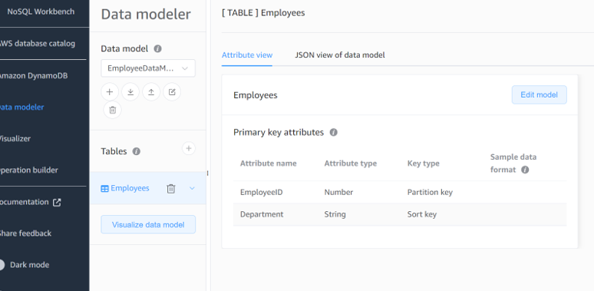
Task:02 – Use all CRUD Operations using console.
Create table using scripts in Cloud Shell.
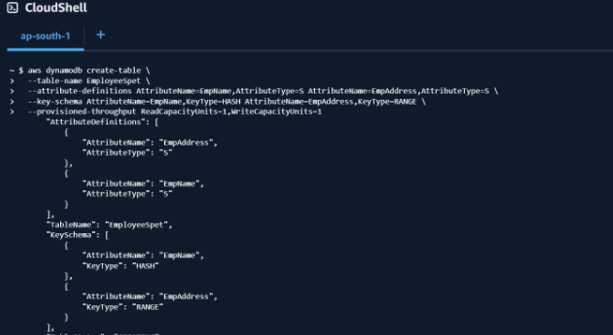

Put item:
Get – Item:
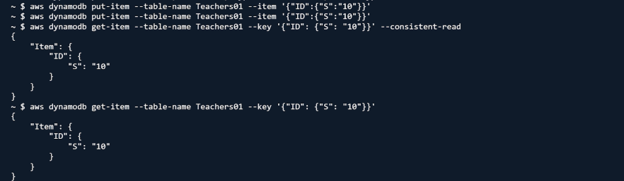
Delete a table:
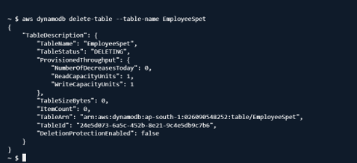

aws dynamodb list-tables (For checking if table is deleted or not)
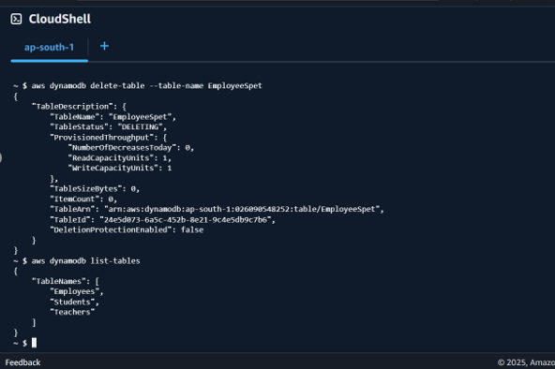

Details of a particular Table: aws dynamodb describe-table --table Students
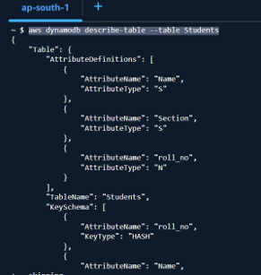

Back of table:
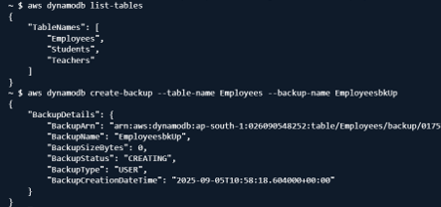
List of Backups:
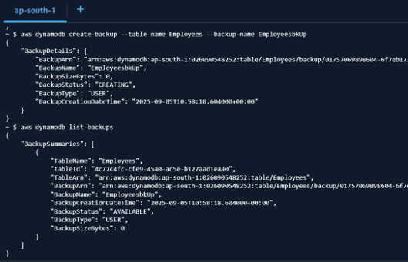
Restore Table from Backup:
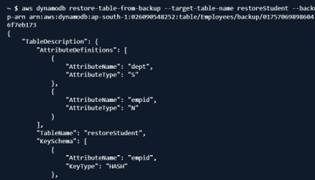

Scan all items in Table:
